Single-Pixel Camera

Operating Manual

Kai Huang

Nelson Huang

Ryan Lin

Lawrence Pang

**Quick Start Guide**

1. Plug the included 12V DC power supply into an electrical outlet
2. Connect the camera to your computer via USB-A (cable included)
3. Scan the QR code and download camera software

**Display-As-You-Go Mode**

The default imaging mode for the camera, this mode enables full user interface features. The following graphic shows the layout and functions of each part of the display.

*Camera Manual Controls*

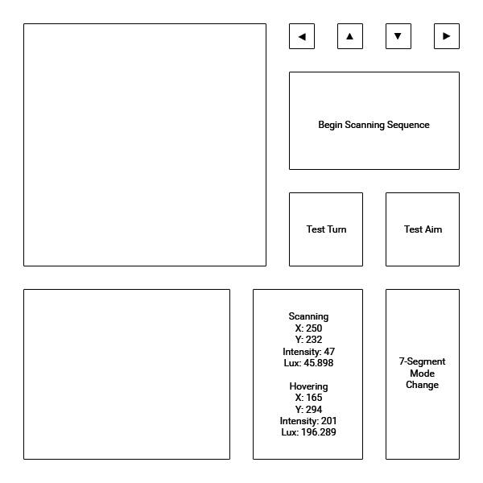

*Histogram*

*Image Display*

*Image Display*

This displays the picture obtained by the camera in grayscale. During the scanning process, the image is drawn in real-time.

For image quality, a simple processing algorithm was implemented to increase the contrast of the picture. Intensity values from the phototransistor are multiplied by a factor of 5. This has the same effect as a long exposure, since at reasonable scan speeds the intensity value obtained by the sensor for each pixel does not vary between rapid samples, thus simply multiplying by 5 is a good approximation for taking 5 intensity exposure readings; however, it is significantly faster.

*Histogram*

This region displays a live histogram as the image is scanned by the camera. The x-axis is exactly 256 pixels in length, with each pixel corresponding to an intensity value from 0 to 255.

*Camera Manual Controls*

These arrow buttons allow manual control over the camera positioning. This is used to aim the sensor at the desired target. Each click of the button turns the corresponding stepper motor by 1 step (0.9 degrees). See **Display-As-You-Go Instructions** for further details on camera alignment.

*Test Aim*

Clicking on this button will cause the camera to move to pixel (1,1), the first pixel to be scanned on the upper-left corner. Since the scanning field of the camera is 300 quarter-steps, or 67.5 degrees, the Test Aim function activates a sequence to move the camera 150 quarter-steps (33.75 degrees) up and to the left. After 1 second, the camera will then return to its initial position to await for user adjustment.

*Test Turn*

This button activates a test sequence for verification of motor operation. Both motors will rotate the full 67.5 degrees and return to the initial position.

*Begin Scanning Sequence*

This activates the full imaging sequence where sensor intensity value is read, processed, and displayed in the image window, and the bottom motor rotates a quarter step, At the end of the current row, the top motor rotates down a quarter step to begin imaging the row below in a S-shaped pattern.

*Pixel Information Display*

The upper section of this display indicates the x, y coordinate of the current pixel being imaged, along with its post-processed intensity value. Using the sensor datasheet, a conversion to real-life luminosity in lux is also displayed.

The lower section displays similar information as the upper segment, but for the pixel at the current mouse position. Simply hover over the pixel of interest.

*7-Segment Mode Change*

This button allows the user to switch between having the x coordinate, y coordinate, or pixel intensity in lux displayed on the 3 seven-segment system on the imaging platform.

**Display-As-You-Go Instructions**

1. Start program
2. Use the arrow buttons to align the camera at the center of the desired target
3. Click on Test Aim to verify that the object of interest is fully within the scan area
4. Click on Begin Scanning Sequence to initiate imaging

**No-GUI Mode**

As the name implies, this mode has most of the user interface removed. The most important difference is that the image is not drawn onto the window and is only available for viewing upon completion of the scanning sequence. The benefit of this mode is an increased scanning speed, with a scan of roughly equal quality as the Display-As-You-Go mode only taking around 10 minutes to complete, in comparison to 20~25 minutes.

**Colour Mode**

This is only available as sample code, currently the camera does not have colour imaging capabilities implemented. The code uses randomly generated values for red, green, and blue - which, in reality, would be sampled from the sensor using a changing colour filter, and creates a colour image.

**Contour Plot**

The exported grayscale image from the camera can be read by a separate program which generates a contour plot of the image.

**Seven-Segment Displays**

Built-in on the imaging platform are 3 seven-segment displays which show real-time values for the x, y coordinates of the pixel currently being imaged, as well as the raw intensity value readings from the sensor. The data displayed is toggled by the 7-Segment Mode Change button on the user interface, described above.